Exp No: 14
EMBEDDED C PROGRAM TO DISPLAY “HELLO WORLD” MESSAGE
AIM :
To write an Embedded C program to display “HELLO WORLD” message using Keil software.
SOFTWARE REQUIRED:
- Keil software
PROGRAM :
#include <reg51.h>
#include <stdio.h>
void main(void)
{
SCON = 0x50; /* SCON: mode 1, 8-bit UART, enable rcv */
TMOD = 0x20; /* TMOD: timer 1, mode 2, 8-bit reload */
TH1 = 0xFD; /* TH1: reload value for 9600 baudrate */
TR1 = 1; /* TR1: timer 1 run */
TI = 1; /* TI: set TI to send first char of UART */
while (1) {
printf("Hello World !\n");
}
}
OUTPUT :
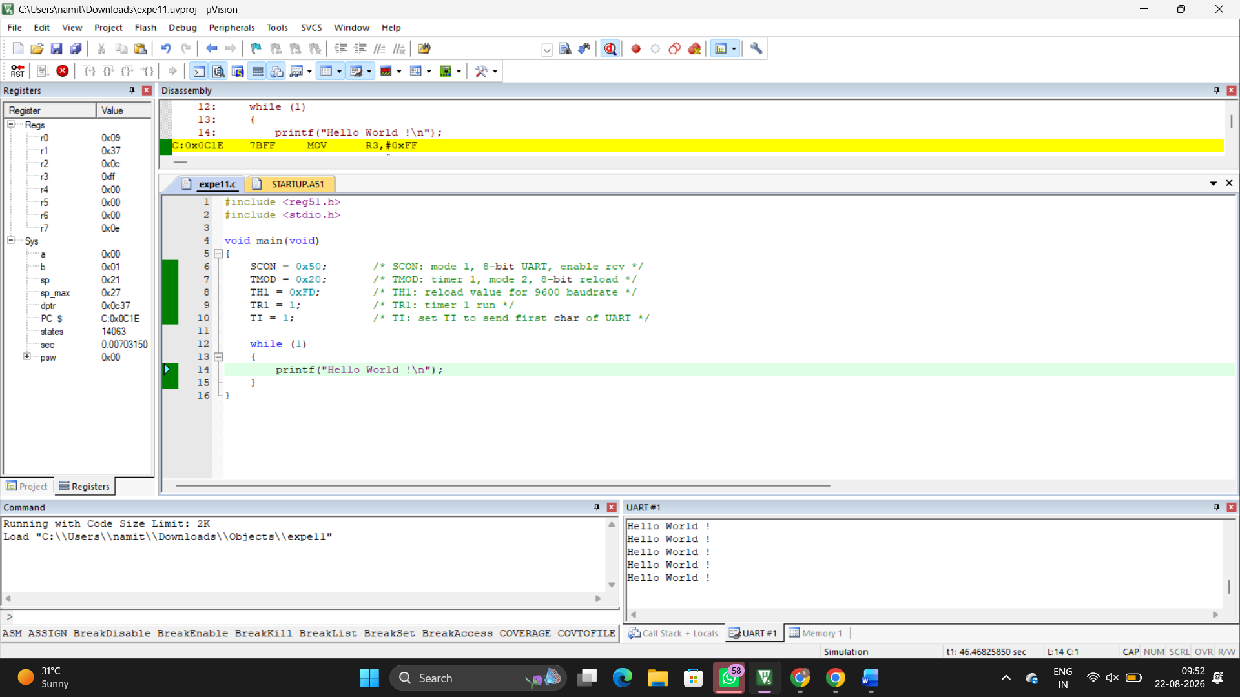
RESULT :
Thus the program has been successfully verified and executed.

